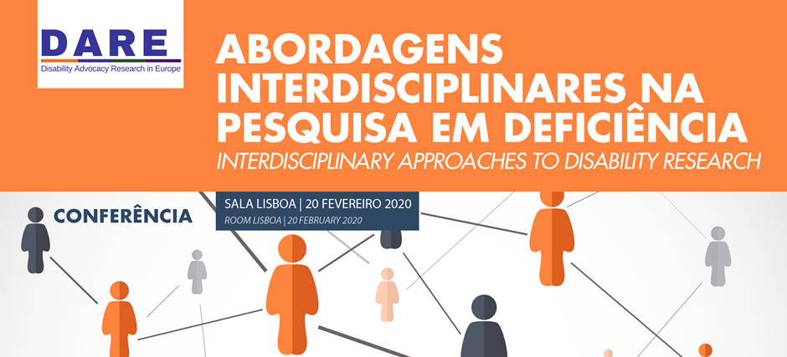

Programme

8h30m Registration

9h00m Welcome and Overview of the DARE Project
Paula Campos Pinto, ISCSP-ULisboa, DARE
Mark Priestley, University of Leeds, DARE
Manuel Meirinho, President of ISCSP-Ulisboa

9h30m Disability Studies, Human Rights and Disability Law – an Agenda for Research
Alberto Vasquez, Research Coordinator at the Office of the UN Special Rapporteur for the rights of people with disabilities

Q&A

10h30m Coffee Break – Sala Monsanto (ground floor)

11h00am Roundtable on Ethics in Participatory and Emancipatory Research
Moderator: Fernando Serra
Speakers: Pat Clarke, Jerome Bickenbach and Megan Smith

This session will be a roundtable discussion on the opportunities and challenges in developing Participatory and Emancipatory Research with disabled people and the ethical issues that may be involved.

Q&A

12h30pm Lunch – Sala Monsanto (ground floor)

13h30m Roundtable on Interdisciplinary Research in Disability
Moderator: Carla Pinto
Speakers: Mark Priestley, Maria Gomez-Carrillo, Tim Ghilain, Teresa J.Pinto

This session will be a roundtable discussion on the opportunities and challenges in developing interdisciplinary research, with a particular focus on socio-legal research.

Q&A

15h00m Coffee Break – Sala Monsanto (ground floor)

15h30m Roundtable on Research Collaborations in Disability Research
Moderator: Jorge Falcato
Speakers: Rannveig Traustadóttir, Anna Lawson, Jorge Manhique

This session will be a roundtable discussion on the opportunities and challenges of collaborating with civil society organisations.

Q&A

17h00m - Close

